TECHNICAL PROJECT REPORT

# Title of Invention / Project: digital rangoli

# Team Members / Inventors:

|  |  |  |  |  |  |
| --- | --- | --- | --- | --- | --- |
| **S. No.** | **Name** | **Department** | **Designation** | **Mobile** | **E-Mail** |
|  |  |  |  |  |  |
| 1. | Hunar narang | ECE | Student | 9779625058 | naranghunar23@gmail.com |
| 2. | Nandita | ECE | Student | 6005501770 | nandita241000@gmail.com |
| 3. | Ishaan | ECE | Student | 9876791930 | ishan7445@gmail.com |
| 4. | Khushal Thakur | ECE | Mentor | 9646030764 | khushal.thakur@cumail.in |
| 5. | Anshul Sharma | ECE | Mentor | 9478697475 | anshulsharma.ece@cumail.in |
| 6. | Kiran Jot Singh | ECE | Mentor | 9463909689 | kiranjotsingh.ece@cumal.in |
| 7. | Divneet Singh Kapoor | ECE | Mentor | 9878422653 | divneet.ece@cumail.in |

Section – 1 (IPR Related)

# Brief Abstract :

* This project is made to reduce the use of chemical colours that are used in rangoli which will not harm environment and hence reduce pollution.Along with it,it will let small children to make their kind of rangoli,instead of rangoli they can draw anything they want.It can be used for decoration purposes.
* Advantages

* It will reduce the work of human hands as it is less time consuming.
* We can draw any kind of design with the use of highlighter.
* It is eco friendly as it does not use chemical colours.

Section – 2 (Real Project)

# Materials

|  |  |  |
| --- | --- | --- |
| s.no | materials | quantity |
| 1 | glass | 1 |
| 2 | blacksheet | 1 |
| 3 | glue | 1 |
| 4 | adapter | 1 |
| 5 | Led strip | 1 |
| 6 | frame | 1 |
| Total cost | 700 rs |  |

BLOCK DIAGRAM

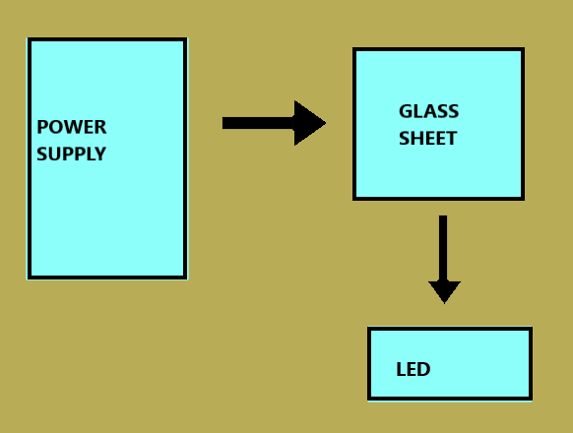

# Steps of Circuit Completion

1. First we took a glass sheet and covered it’s back with black sheet.

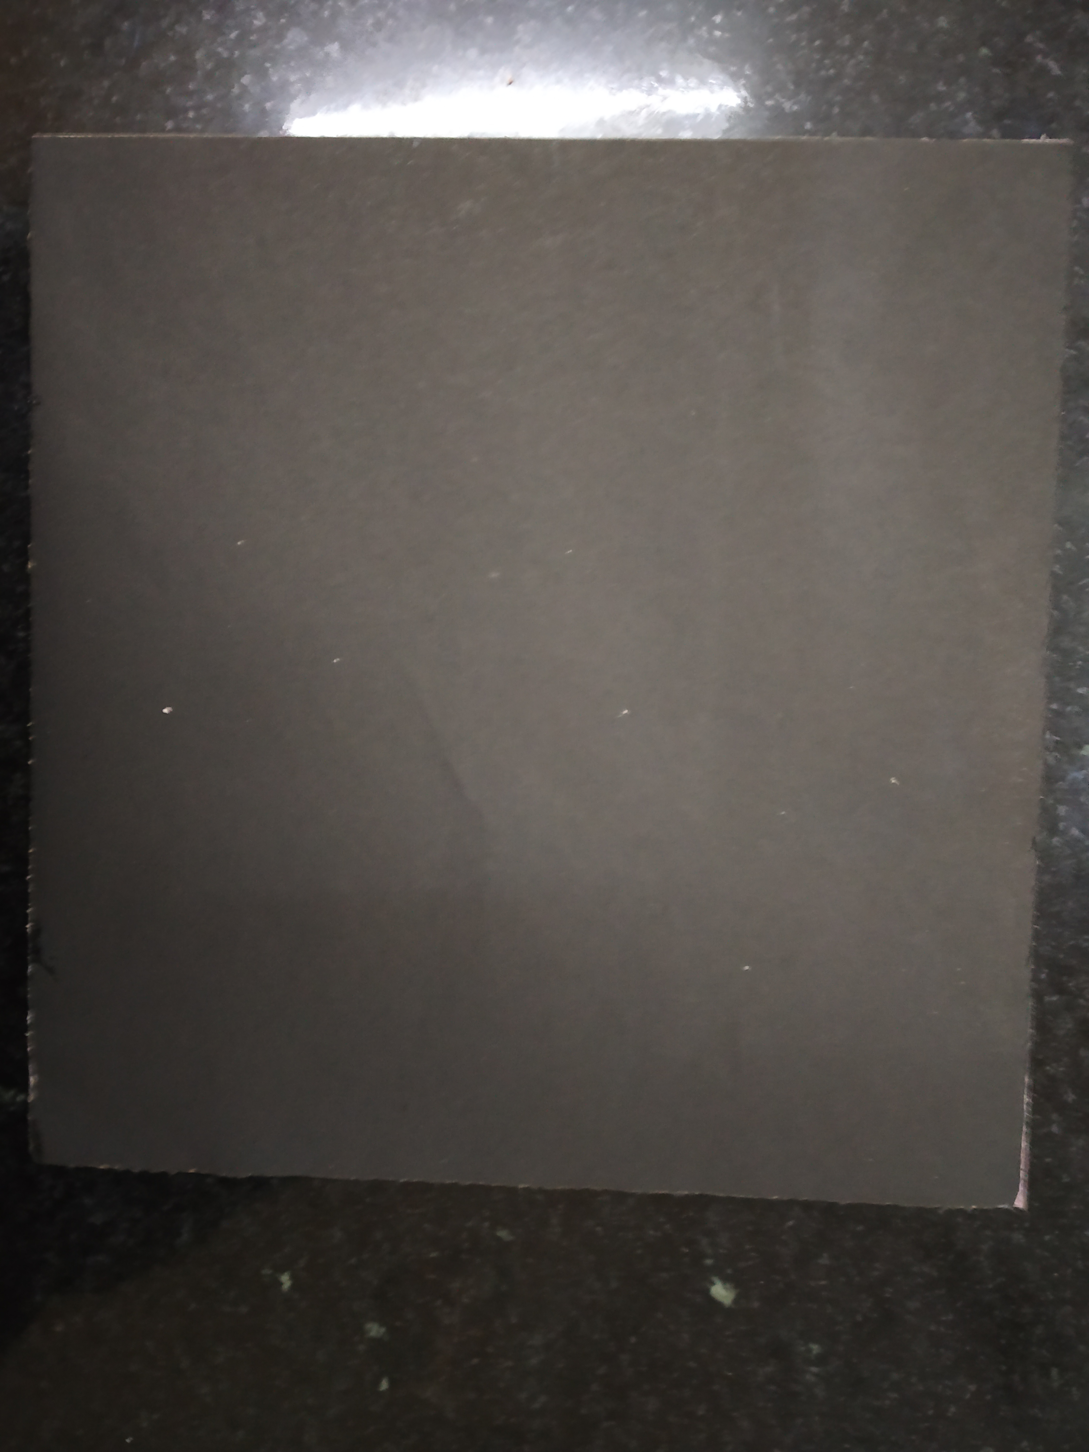

2.After that we joined led light strips along with the corners of glass sheet and connected led strips with adapter which will provide the flow of electricity when applied to a switch.

# 

3.Then we framed the whole glass.

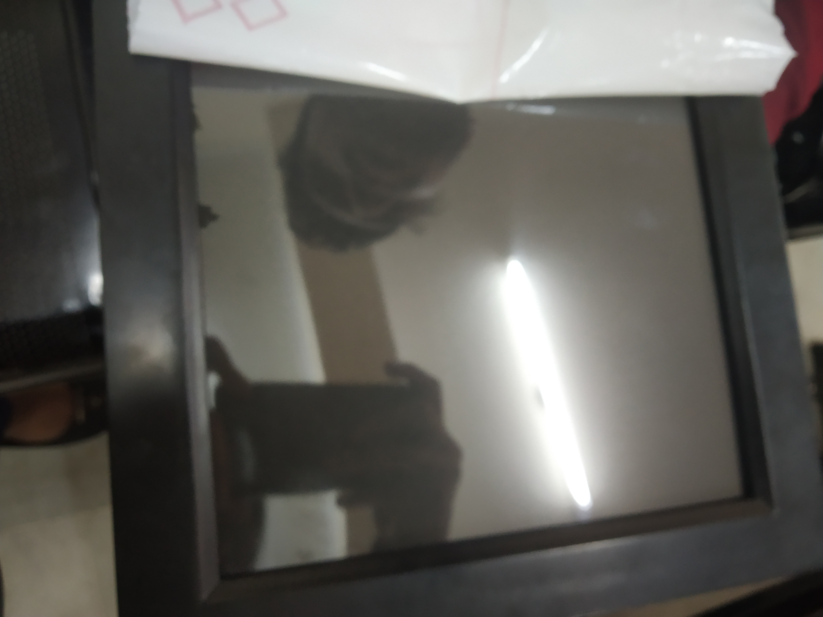

# Program Code

https://github.com/beeeproject123/ledrangolli